Access Guide for Theatre Works

This Access Guide was created by Alanah Guiry and Rachel Neparstek. This access guide uses 14 pt in Arial font and uses 1.5 spacing. There are no italics but there is Bold. This Access Guide has 23 pages and contains photographs, a video tour and diagrams of the venue.

Acknowledgment of Country

Theatre Works acknowledges First Nations’ sovereignty and recognises the continuing connection to lands, waters and communities by Traditional Owners of Country throughout Australia. We pay our respects to Aboriginal and Torres Strait Islander cultures; and to Elders past and present. We support and contribute to the process of Reconciliation.

Always was, always will be, Aboriginal land.

Theatre Works is located 14 Acland Street, St. Kilda on the stolen lands of the Boonwurrung and Woiwurrung people of the Kulin Nation. You can read about the history of Theatre Works on the website. https://www.theatreworks.org.au

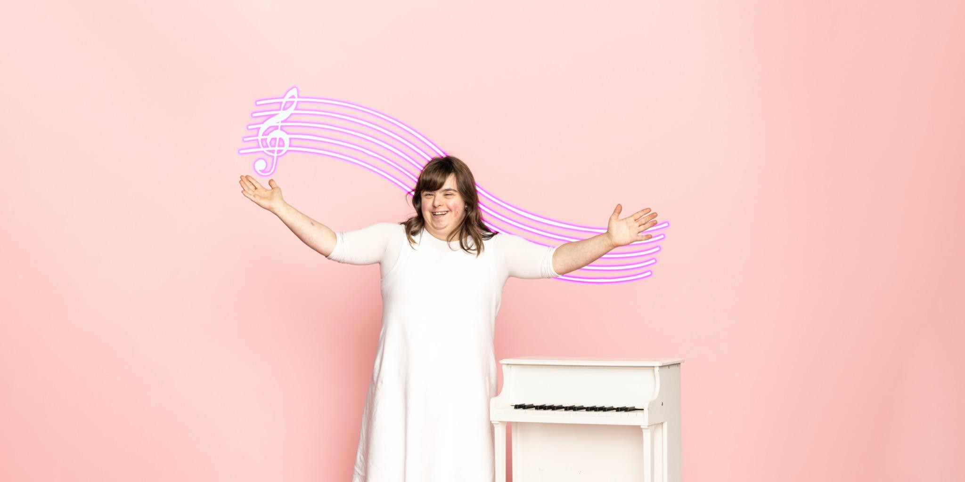

Image Description: A white woman with brown hair in a ¾ sleeve white dress laughs with her arms spread wide. She is next to a small white piano. Behind her is a cartoon treble clef with purple cascading music staff lines.
The background is baby pink.

Contents:

- Getting to the venue
  - Public Transport
  - Parking
  - Accessible Parking
  - Images of Accessible Parking
- Theatre Works Box Office Hours + Black box cafe + Bar
  - Office Hours
  - Cafe
  - Bar + Bar Menu
  - What to wear to the theatre
  - What to bring to the theatre
- Venue Information
  - Lighting
  - Sound
  - Toilets
  - Venue Tour + Diagrams
  - Seating
  - Railing
- Before, during and after Performance Information
- Support

Getting to the venue Theatre Works Address 14 Acland Street
St Kilda VIC 3182
Australia

Public Transport
Theatre Works is easily reached by public transport. Tram and bus services provide regular stops and pick-ups within the Fitzroy and Acland Street shopping precincts, both just a short walk from Theatre Works.
Tram: 12 & 16
Light Rail: 96
Buses: 600 Southland Shopping Centre to St Kilda Station / 623 Glen Waverley to St Kilda Station / 246 Elsternwick to Clifton Hill.

Explosives Factory can be accessed by public transport. Tram and bus services provide regular stops and pick-ups from Barkly Street and the Nepean Highway/ St Kilda Road stations.
Tram: 3/3a and 67
Buses: 600, 246, 922 and 923.

Parking Options
Theatre Works has two accessible parking spots available in front of the venue (as pictured below).

Parking can be difficult in St Kilda. We recommend arriving early and leaving yourself plenty of time for parking.
Alternatively, you could use the paid car park at the Prince of Wales Hotel which is located on the corner of Acland and Fitzroy Streets (for access to Theatre Works).

Accessible Parking
There are two accessible parking spots at the front of Theatre Works. The first image below is a photograph of where the two accessible parking lots are located. The second image is a screengrab of a map that shows where the two parks are located on the street from a birds eye view. The two pink circles mark Accessible Parking on the map. The Yellow/ Pink star marks the audience entrance to the foyer.

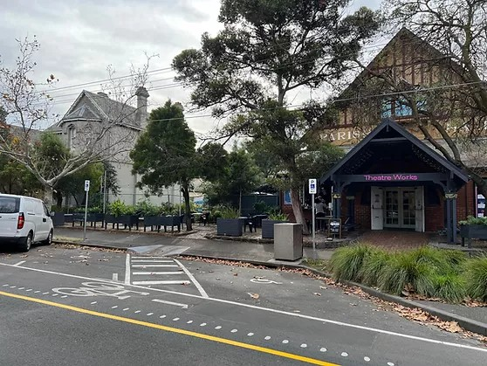

Image Description: A photograph of the two accessible parking spaces that lead into Theatre Works foyer.

Map View
A screengrab of a map where the two accessible parks are located.

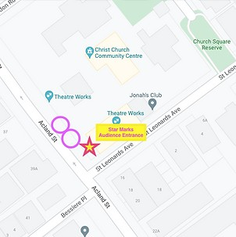

Image Description: This is a screengrab of a map that shows where the two accessible parks are located on the street from a birds eye view. The two pink circles mark Accessible Parking on the map. The Yellow/ Pink star marks the audience entrance to the foyer.

Theatre Works Box Office Hours
The Theatre Works Box Office is open 45 minutes prior to the scheduled show start time. Come in, collect your tickets, have a drink and chat with our friendly box office crew.

Theatre Works Blackbox Cafe
Open for your daily caffeine hit and sweet treats (cakes and vegan friendly slices).
Monday to Friday, 7:30am-1:30pm Saturday, 8am-2pm
Sunday, closed

You can order at the cafe through the open window. The cafe is cash free.
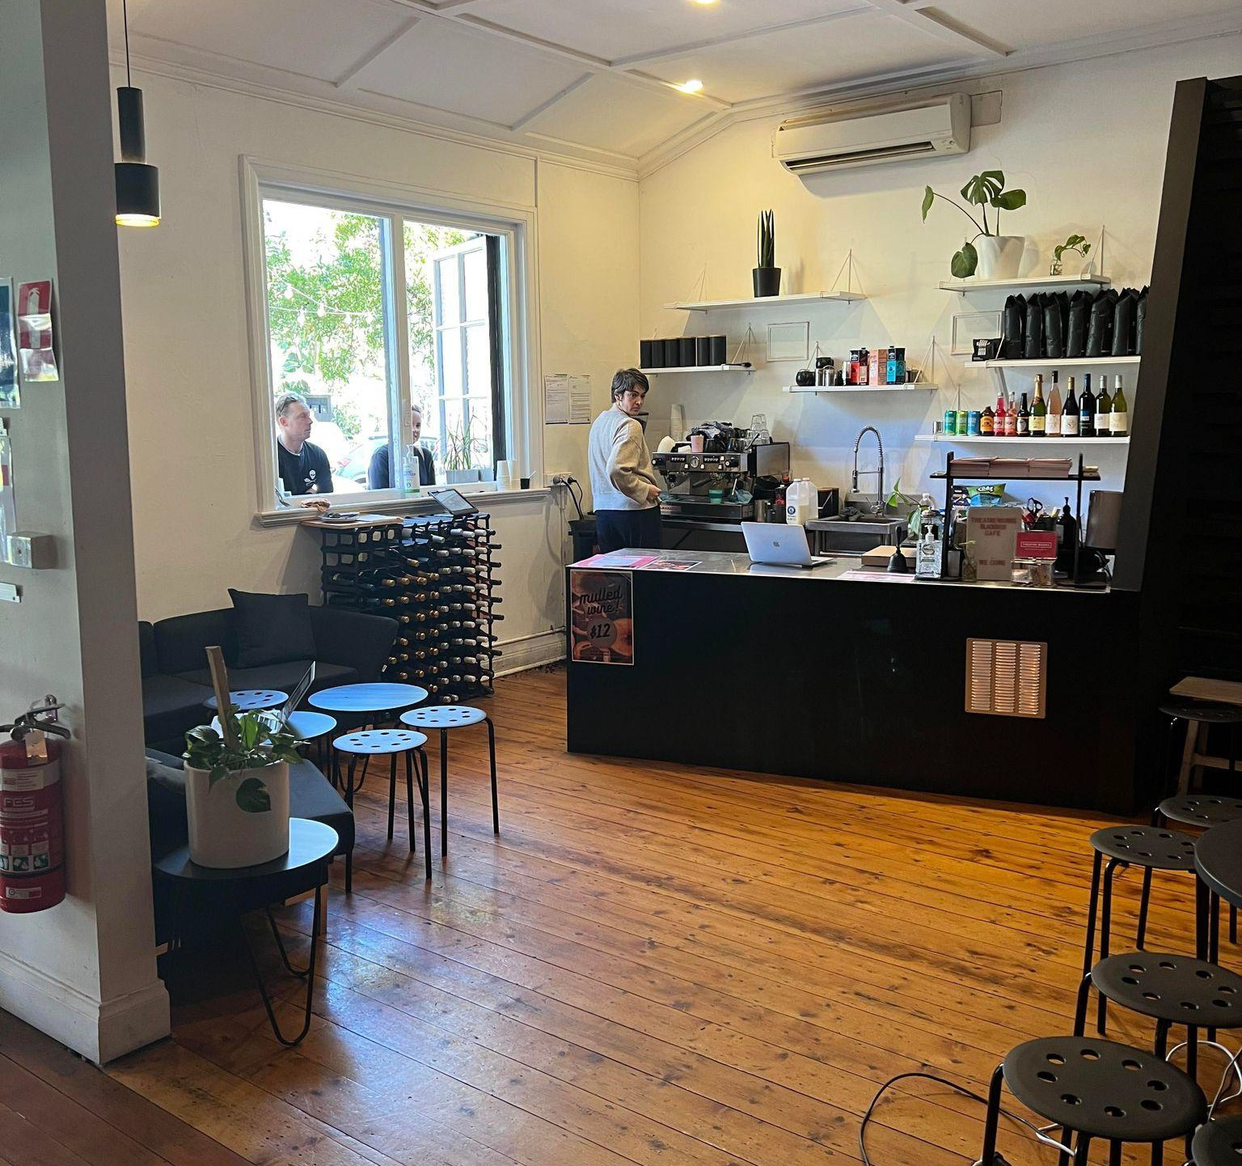
You can sit inside the cafe if you would like or outside.

The image below is a photograph from inside the cafe. Meg is behind the cafe at the coffee machine. The cafe has oat milk, cows milk, soy milk and almond milk.

Image Description: Meg who has short hair and a grey jumper is facing the coffee machine in the far left.
There are two customers at the service window. The rest of the photograph is taken up by the wooden foyer floor and black stools.

Theatre Works Bar
The Theatre Works bar opens one hour before the performance begins. (The Explosive Bar opens half an hour before)
Our bar is cash free which means we only accept card payments. We use Square pay. You can tap, swipe or insert your card. You can choose to have a receipt by clicking the receipt button.
There will be an employee behind the bar to serve you. Sometimes they might be getting extra stock from out the back and you will need to wait a few minutes. They might say “How are you?” or “What can I get you?” and you can then tell them your order.
There is often a que for the bar and you will need to wait your turn They will prepare your order for you.
You are welcome to bring your drink into the theatre. The night time bar menu is on the next page.

Bar Menu
This is a copy of the bar menu used at the theatre.

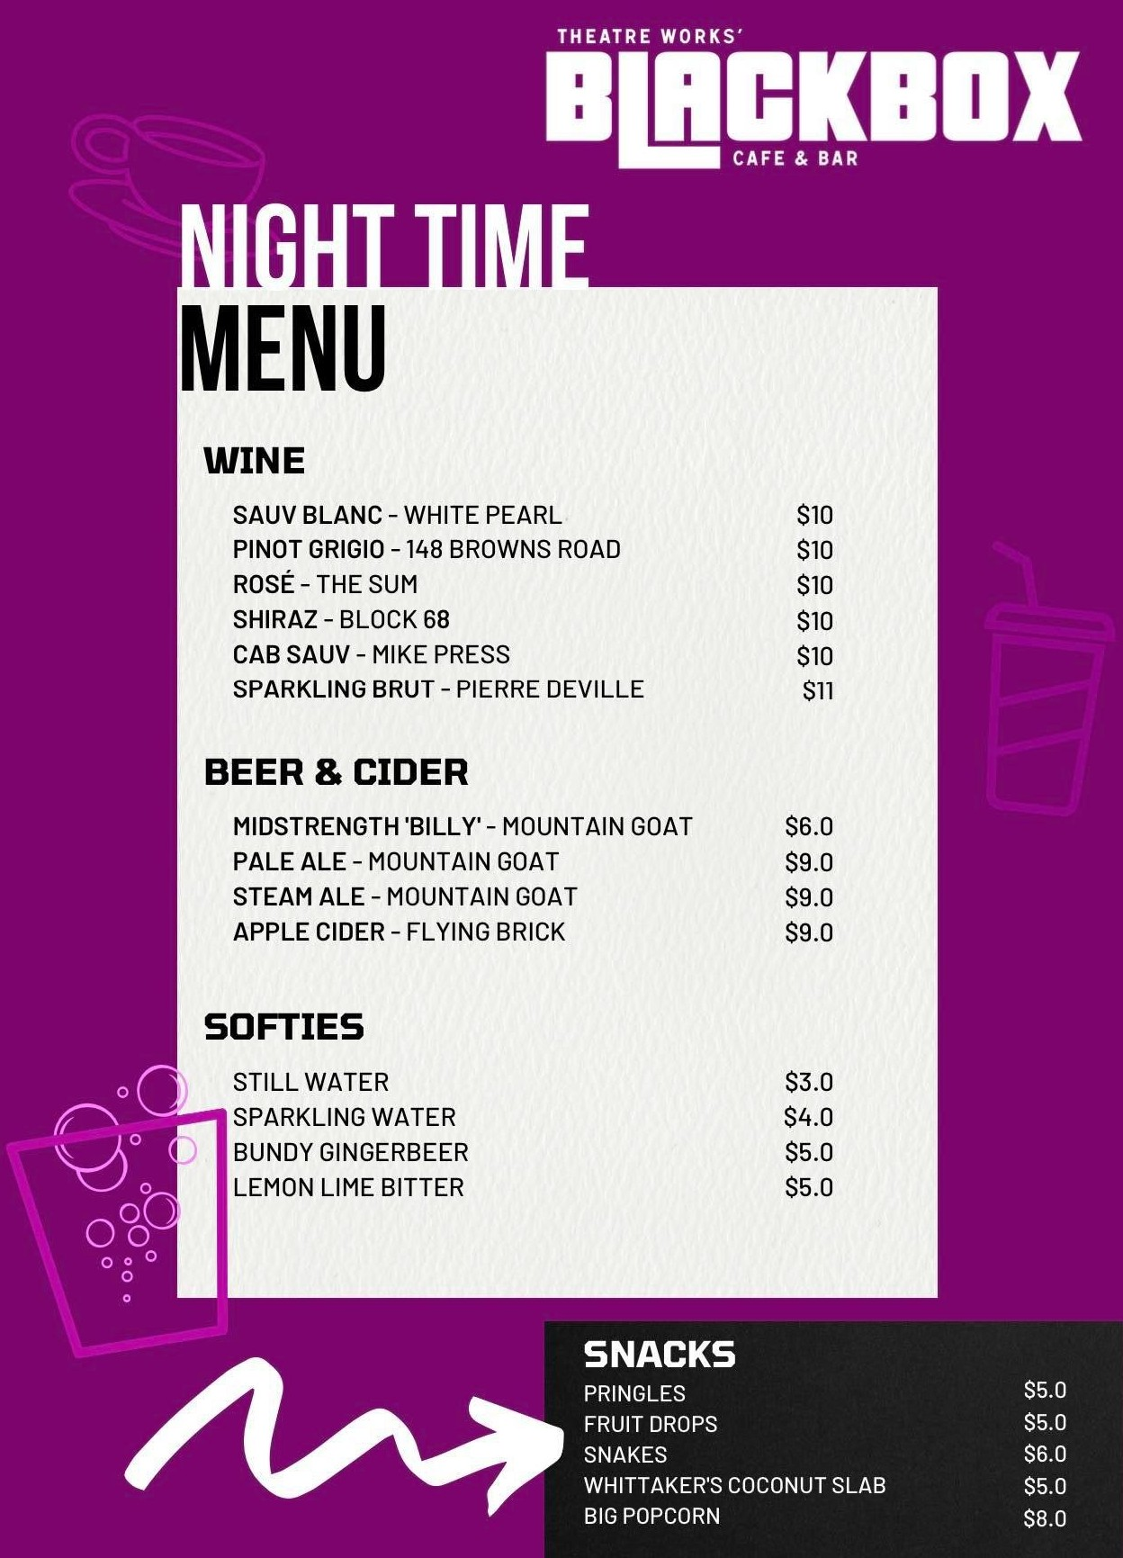

What do I wear to Theatre Works?
Casual, comfortable clothes. There is no dress code and what makes you comfortable makes us comfortable. If it’s a cold night, we would recommend wearing warm clothes. There are standing heaters outside.

What do I bring?
A mask is recommended. Your ticket (digital is preferred). Assistance dogs are welcome in all venues.

Venue Information
The Theatre Works venue has been repurposed into a theatre from a church. During the day, Theatre Works runs as a cafe. During the night, Theatre Works runs as a performance venue.

Lighting
The foyer at Theatre Works is lit by daylight from the street and warm LED lights.
The bar at Theatre Works is lit overheard with LED lights.
The hallway that leads to the theatre has lower lighting than the foyer and bar.
The bathrooms are lit with fluorescent lights.
The outside area is quite dark after sundown, with some white hanging lights for ambience.
There are some street lights but the streets surrounding Theatre Works can be quite dark.

Sound
There will be music playing at a low level in the bar and foyer at Theatre Works.
The music from the bar may be heard in the foyer.
The bathrooms and outside area do not have any music but you may hear the foyer music.

Toilets
There are two bathrooms at Theatre Works. These are gender neutral. The toilet on the left is Accessible. There are instructions on the door.

How To Use The Accessible Toilet
- Push The Green Button To Open
- Enter The Bathroom
- Push The Black Lock Button For The Door To Close
- Wait For The Door To Close Automatically. Do Not Manually Close The Door.
- The Door Sometimes Gets Stuck, But You Can Not See Inside The Cubicle.
- Push The Green Button To Open.

Video Venue Tour
Rachel is an Associate Artist at Theatre Works. She developed her musical ‘The Dream Room’ in 2022 with Theatre Works. Rachel gives a venue tour in the youtube clip below. You can click here to see the video. There are captions in the clip.
You can click here for Rachel’s venue tour.

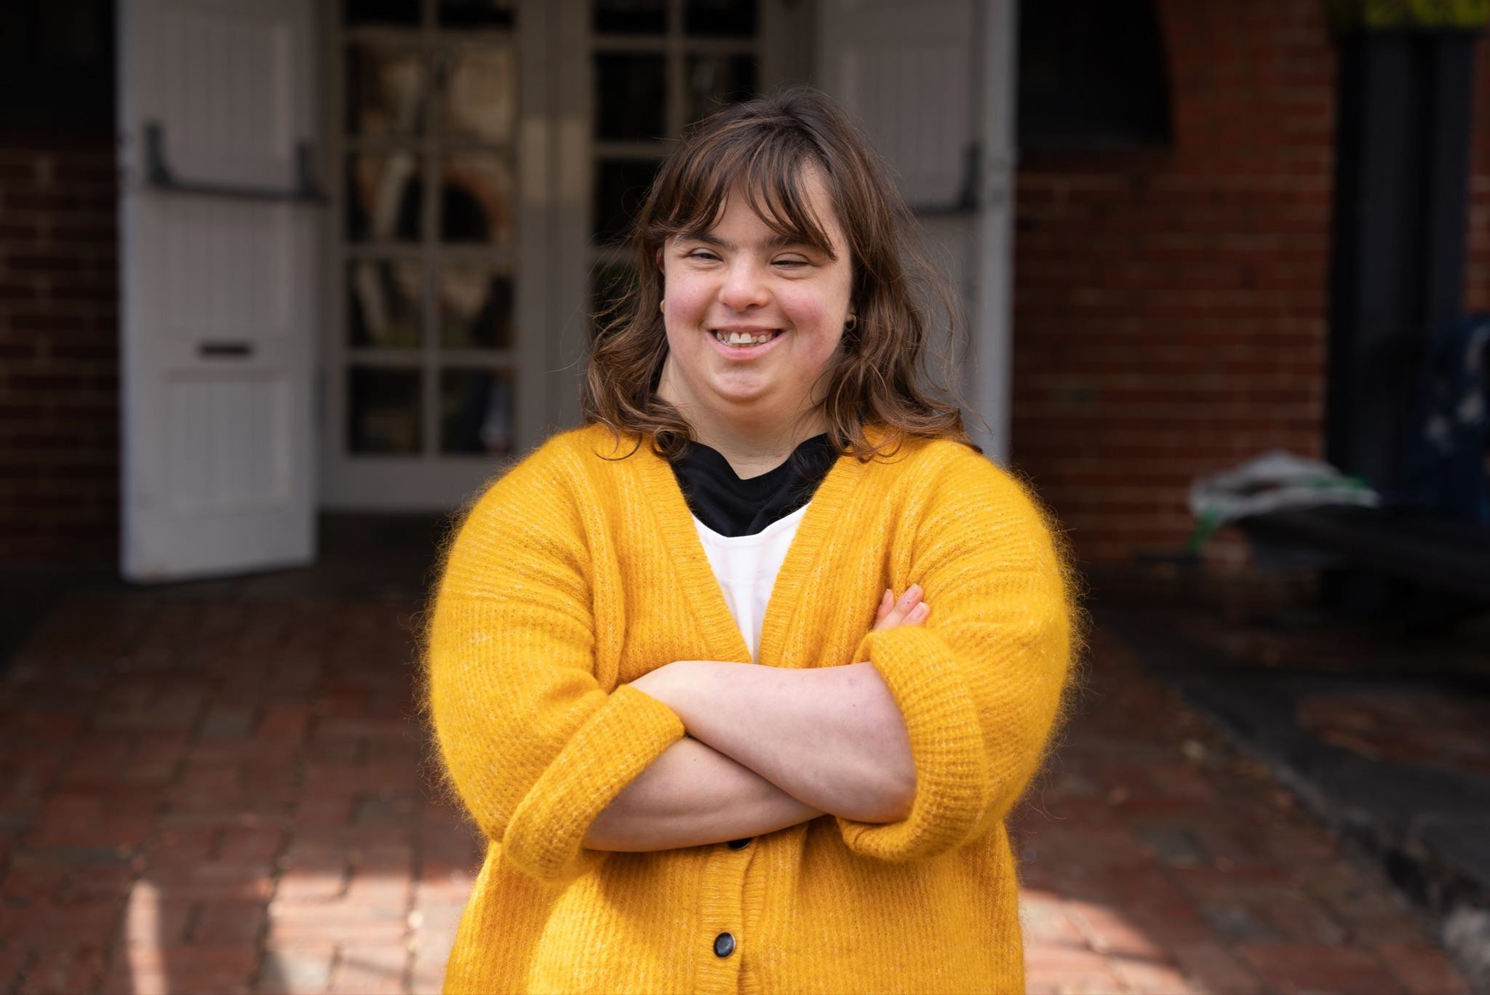

Image Description: Rachel has brown straight hair with a fringe that ends just above her eyebrows. She has her arms crossed over her chest. She wears a fluffy mustard cardigan with a white + shirt underneath. She is smiling at the camera.

Birdseye Diagram of Foyer and Outside Area
This diagram is not to scale but shows the structure of Theatre works.

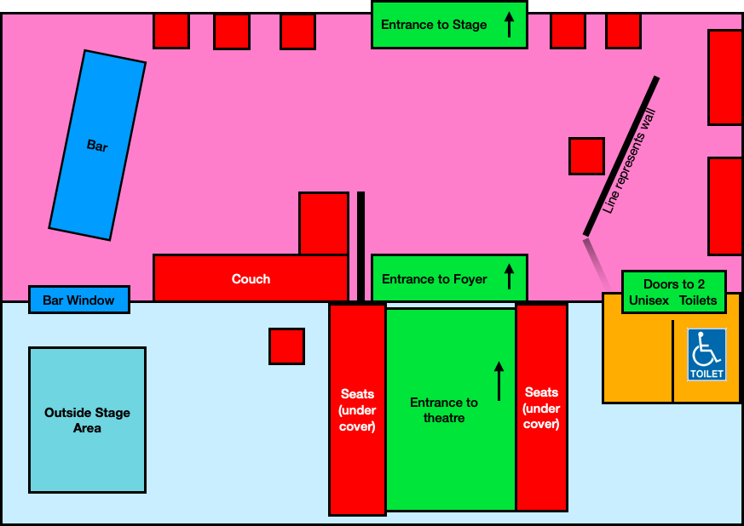

Birdseye Diagram of Stage and Seating
This diagram is not in scale but demonstrates how the performance space is structured.

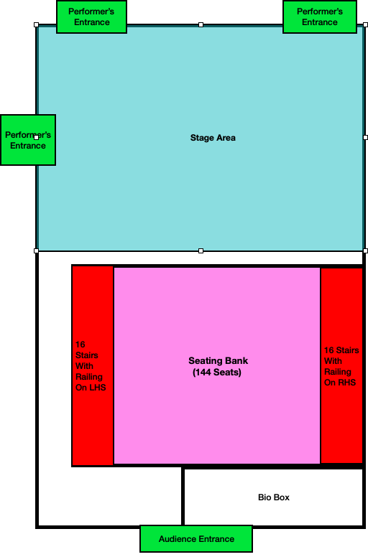

Image of Seating Bank
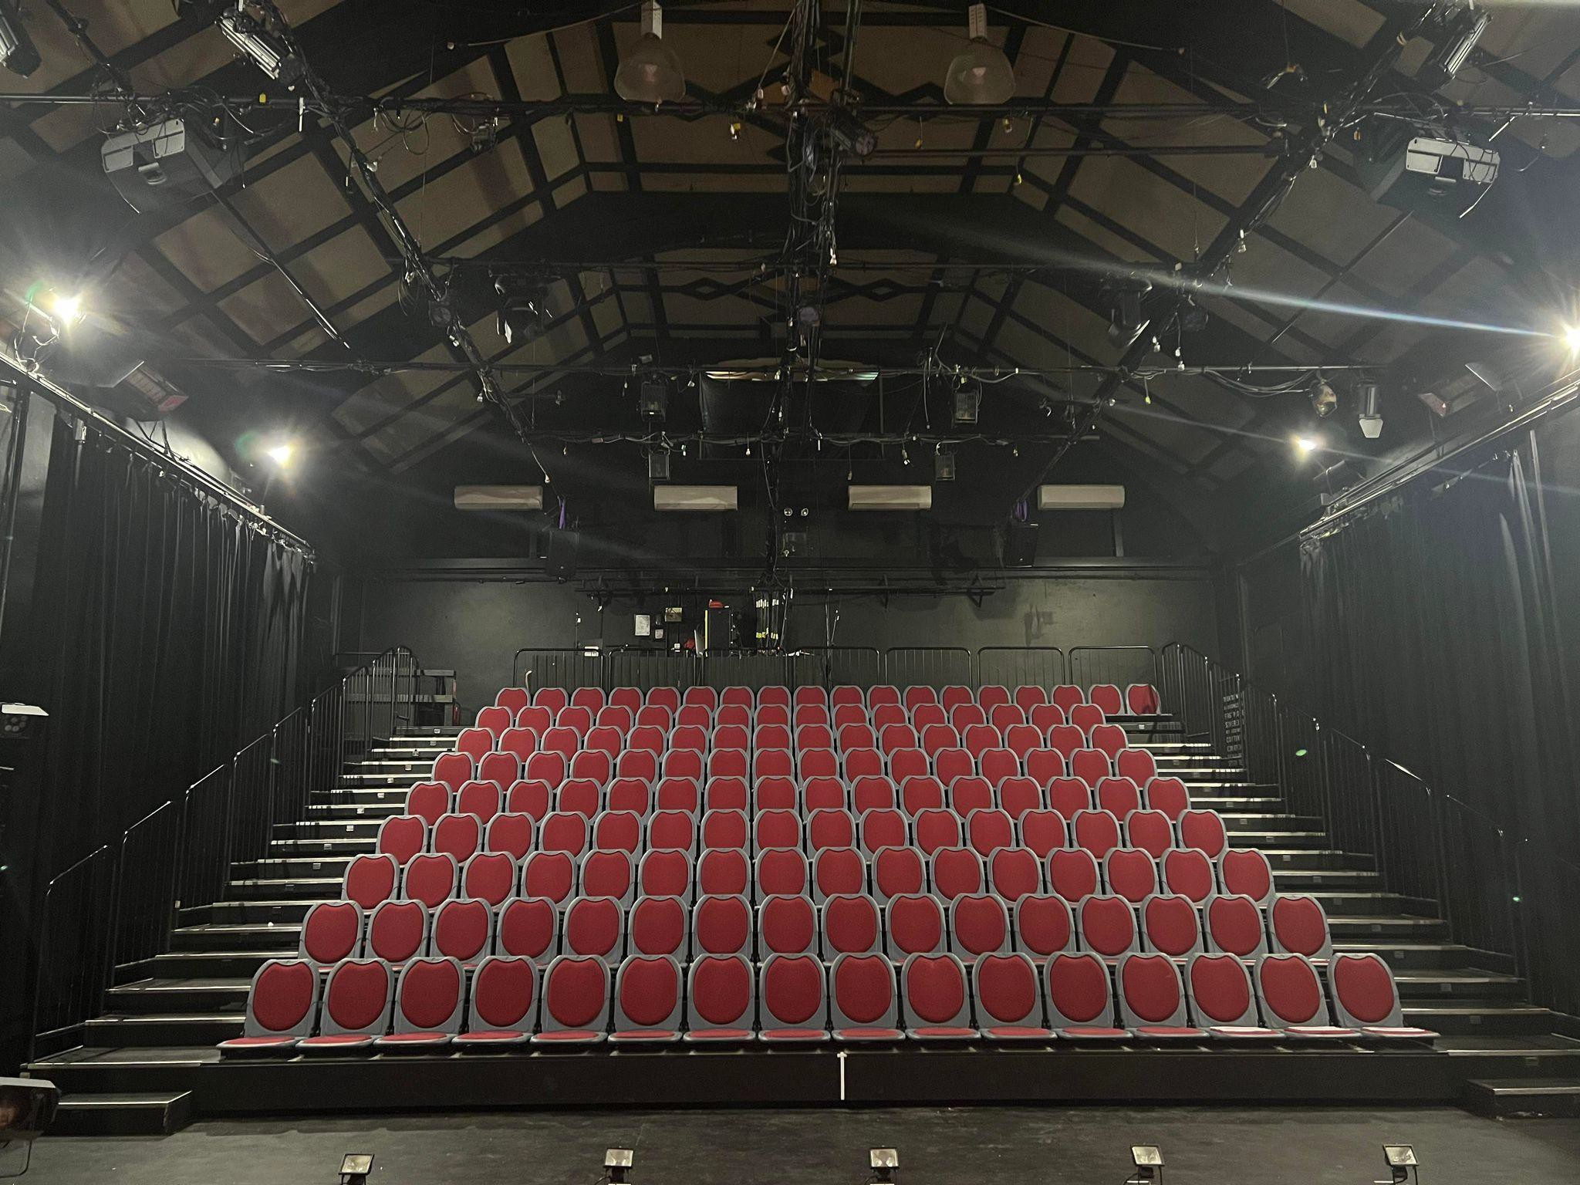
Image Description: This is an Iphone photograph of the 144 red seats with grey sides with the house lights on.

Seating
There is general seating at Theatre Works. This means that there are no numbers allocated and that you can choose your own seat. The seats have red cushions on them with grey plastic surrounding the cushion. There are no armrests. There is no room to put a bag under your seat. There is no room to put bags or coats under the seats. The seats fold down easily.
They sometimes make sounds when you move on them.
There are two rails on either side of the stairs. Theatre Works does not have allocated seating so there are no numbers on the seats. You are welcome to sit wherever you prefer. If the show is sold out then you will be asked to sit in any available seat.

Sometimes there will be a few seats that are reserved. They will have a sign placed on the seat saying “RESERVED”. Do not sit in those seats.

Stair Rails
There are 16 stairs in total to the top of the rafters.
The stairs range from 15.5 cm and 16 cm. The stairs have rails that can be used for support. The rail sometimes makes a rattling sound when pressure is put on it but they are secure.

Before, during and after Performance Information

When do I enter the theatre?
The Front of House staff will ring a bell five minutes before a show and open the doors to the theatre. You will then enter and find a seat. The house lights will be on. The audience will then turn off their phones or technological devices to not distract the performers.

Before the Performance
When the audience is seated and the performers are ready, the house lights will go down slowly and the theatre doors will close. The audience will then be quiet. An ‘Acknowledgement of Country’ or ‘Welcome to Country’ will be either spoken out loud or through a voice over. The show will then begin. If the show is not a relaxed performance, then you will be required to remain seated throughout the performance. Sometimes, shows will have a lockout policy (this means that if you exit during the show you cannot come back in). It is recommended to go to the bathroom before a show begins so you do not have to leave.

During the Performance
When the show is on, the audience will react. If something is funny, they may laugh. If something is sad, they may cry. There is no right way to enjoy a show.

After the Performance
When the performance is over, the lights will go down. The house lights will come back up. The actors will sometimes come out of character. The actors will often bow. The audience will applaud. If someone really loves the show, they may stand up and clap for the actors. Then, the audience will vacate the theatre space. They may choose to hang around after the show to congratulate the actors or talk about the show with other audience members. You are welcome to leave as soon as the show is finished.

Support

Support Act Wellbeing Helpline
1800 959 500
24/7

Beyond Blue
24/7
1300 22 4636

Headspace (12 - 25 year olds)
10am - 1am 1800 650 1800

Parentline 8am - 12am 13 22 89

Safe Steps (Family Violence Response Centre)
24/7
1800 015 188

Sexual Assault Crisis Line
5pm - 9am 1800 806 292

Lifeline

24/7
13 11 14

SANE
10am - 10pm 1800 187 263

ARAFEM - Carer Helpline
9am - 5pm 1300 550 265

