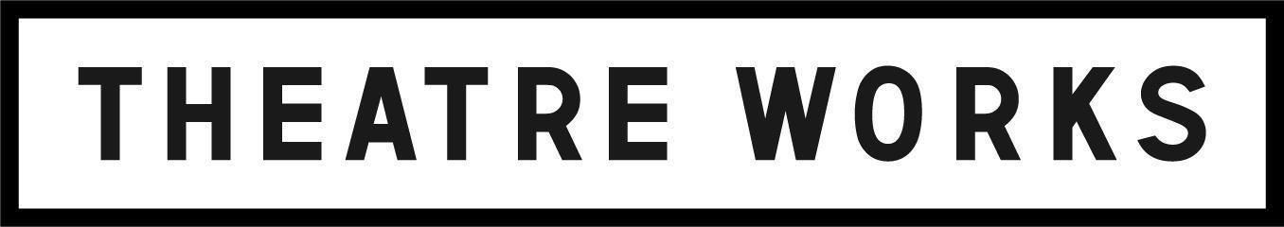
Please email this completed form to: admin@theatreworks.org.au
For more info contact: (03) 9534 3388

School | Date
Teacher | Position
School Address
 | State | Postcode
Telephone | mobile
Email

- Regional and low ICSEA school / $20 (per student)
- Metro schools: $30 (per student)
- Accompanying teachers: Free (up to 2 per group of 20)
- Additional teachers: $40 per ticket
DATE | TIME | NO. STUDENTS | NO. FREE TEACHERS | NO. PAID TEACHERS | COST PER STUDENT  ($20 or $30) | COST PER PAID TEACHER ($40) | TOTAL COST
Sat 30 Jul | 7:30pm
Tue 2 Aug | 7:30pm
Wed 3 Aug | 7:30pm
Thu 4 Aug | 11:00am
Thu 4 Aug | 7:30pm
Fri 5 Aug | 11:00am
Fri 5 Aug | 7:30pm
Sat 6 Aug | 7:30pm
Tue 9 Aug | 7:30pm
Wed 10 Aug | 11:00am
Wed 10 Aug | 7:30pm
Thu 11 Aug | 11:00am
Thu 11 Aug | 7:30pm
Fri 12 Aug | 11:00am
Fri 12 Aug | 7:30pm
Sat 13 Aug | 7:30pm
DATE | TIME | NO. STUDENTS | NO. FREE TEACHERS | NO. PAID TEACHERS | COST PER STUDENT  ($20 or $30) | COST PER PAID TEACHER ($40) | TOTAL COST
Tue 16 Aug | 7:30pm
Wed 17 Aug | 11:00am
Wed 17 Aug | 7:30pm
Thu 18 Aug | 11:00am
Thu 18 Aug | 7:30pm
Fri 19 Aug | 11:00am
Fri 19 Aug | 7:30pm
Sat 20 Aug | 7:30pm

- We are offering additional flexibility through our refund policy at this time, having regard to the uncertainties posed by COVID-19:
  - If tickets are cancelled by Theatre Works for any reason in connection with COVID-19, you will be entitled to a full refund of every ticket price
  - You will also be entitled to a refund or exchange if you or a member of your booking party falls into any of these categories:
    - a. You or they are required to self-isolate or quarantine (and the event falls within the isolation/quarantine period) due to:
      - i. being a confirmed case of COVID-19; or
      - ii. having close contact with a confirmed case of COVID-19; or
      - iii. living in or having been in a high risk area within Australia; or
      - iv. having returned from overseas.
    - b. You or they have COVID-19 symptoms, have been tested for COVID-19 and are awaiting test results (and the event falls within the period of awaiting test results). The symptoms of COVID-19 include: fever, chills or sweats, cough, sore throat, shortness of breath, runny nose or loss of sense of smell.
  - You must contact us as soon as possible if you or a member of your booking party falls into any of these categories.

